

ZOOM USER MANUAL

FOR STUDENTS AND TEACHERS

**CREATED BY**

**KATE HENNION**



Welcome



OUR PURPOSE



Welcome to Code for Nepal! We are a non-profit organization focused on increasing digital literacy for Nepali citizens. We are so excited to work with you as you enhance your basic knowledge of digital technologies.

What is digital literacy? It provides people with the knowledge and skills to positively interact with the digital world. The specific digital literacy competency covered in this manual is Communication and Collaboration. These are important skills to have when using online resources as students and professionals.

This manual is designed for students and teachers who utilize the Zoom platform in their classrooms. Zoom is a program that enables virtual collaborations, allowing you to interact with your peers from a distance and connect with people all over the world!

The goal of this manual is to teach students and teachers to use Zoom, and effectively connect with communities around the world. Let’s get started!

1



BEFORE WE BEGIN, MAKE SURE YOU HAVE A



Cellphone



Computer



Email

2



PART 1: Create an Account

1. Go to zoom.us in your browser

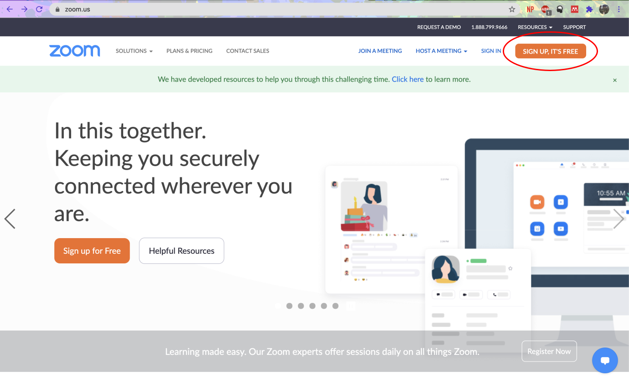

1. Click SIGN UP, ITS FREE
2. Enter your Birthdate and Email address
   1. Or sign up with an already existing account through Google or Facebook
3. Check your Email for a confirmation link à Click Activate Account
4. Type in your first and last name
5. Create your Password
6. Click continue
7. You are now at your main account page!

3



PART 2: Download Zoom

On the Computer

1. Go to zoom.us/download

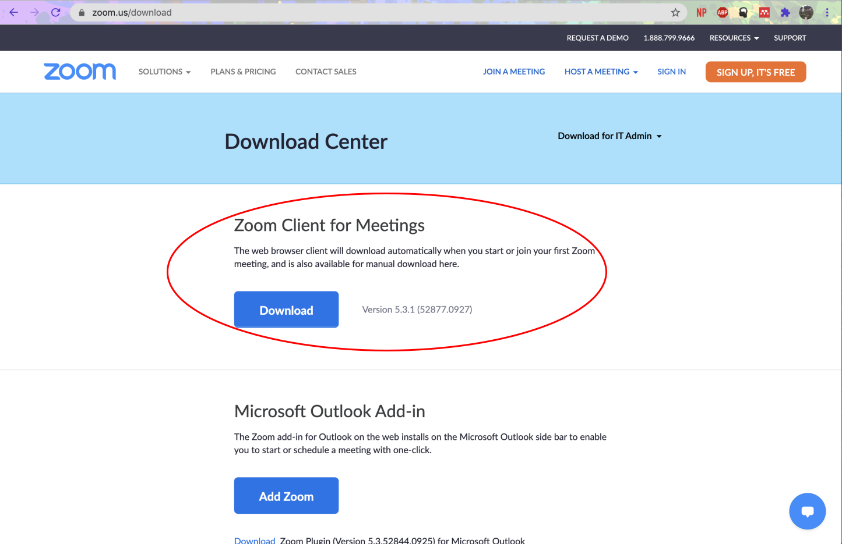

1. Click on ZOOM FOR CLIENT MEETINGS
2. Follow the instructions on your computer to install the program
3. Once installed, click to Zoom.us icon on your computer and log in



4



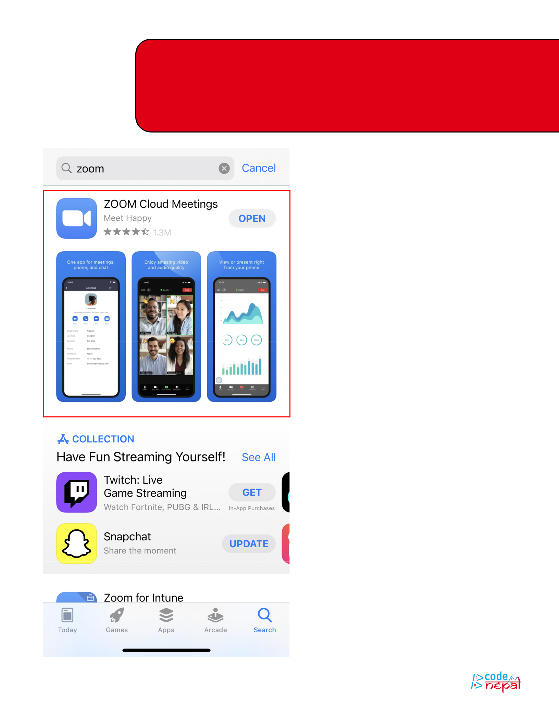Continued: Download Zoom

On the Cellphone

1. Go to your app store and type in Zoom
   * Android: Google Play Store
   * Apple: App Store
2. Click ZOOM CLOUD MEETINGS
3. Follow prompts on phone
4. Sign in or join a meeting

5

PART 3: Zoom Features

General

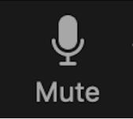

MUTE

Mute and unmute yourself by clicking the microphone in the bottom left.



VIDEO

Show and hide your video so participants can see and interact with their peers.

SECURITY

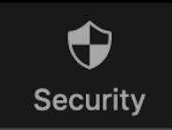

Control the meeting by locking it and inviting people from the waiting room. You can also control which participants are able share their screens, type in a chat, rename themselves, and unmute themselves.

PARTICIPANTS



View who is participating in a meeting and elicit responses from them. Participants can respond to information nonverbally via buttons on their participant screen: yes, no, go slower, go faster, a thumbs down, thumbs up, hand clap, tea, and clock function. The host has the option to mute all and can request individual actions by scrolling over a name.

CHAT

Send both public and private messages to participants by selecting the person you want to chat with. The host can adjust the settings of the chat feature by allowing participants to chat with no one, host only, everyone publicly, and everyone publicly and privately. Once the session is over, Zoom will automatically download and save a copy of the chat. The host can see all messages in the chat, both private and public.



RECORDING



You can record a session by clicking the “recording” button on the bottom on the screen. When it is recording there will be a red, flashing circle in the top right corner of the screen. The zoom recording will be saved and sent to the host via email and show up under the “recordings” tab on the main page for teachers to access later.

END

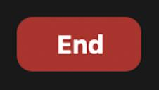

To end a meeting click the red box that says “End.” You can end the meeting for all or choose to leave individually

6



Continued: Zoom Features

Interactive Elements



CLOSED CAPTIONING

For more accessible meetings you can have the audio displayed on the screen

1. Click the button that says Closed Captioning
2. Adjust the settings to a participant typing, the host typing or a 3rd party CC service via a link

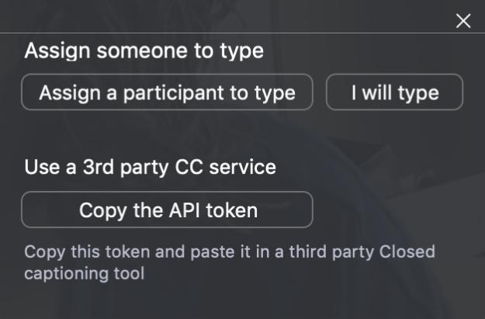

REACTIONS

These images show up in the top right corner of the screen to show students interest in material:

* Clapping emoji
* Thumbs up,
* Heart,
* Laughing face,
* Surprise
* Celebration



* Celebration

POLLING

Polling is another great option for teachers where you can create questions for students to interact with material.

1. Click Edit

2. Log into account on browser

3. Click Add or Edit Poll

4. Enter question and answer choices

5. Hit submit

6. Hit Launch Poll

7. View Results

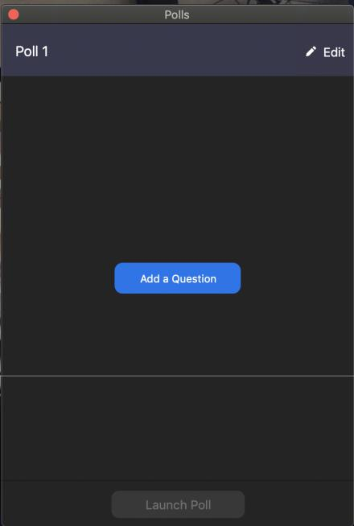

7



Continued: Zoom Features

REACTIONS

BREAKOUT ROOMS

Click to sort people into smaller groups

1. Click the button that says Breakout Rooms
2. Click the number of participants you want in a room
3. Choose to automatically or manually assign people to rooms
4. Adjust the settings under the options tab

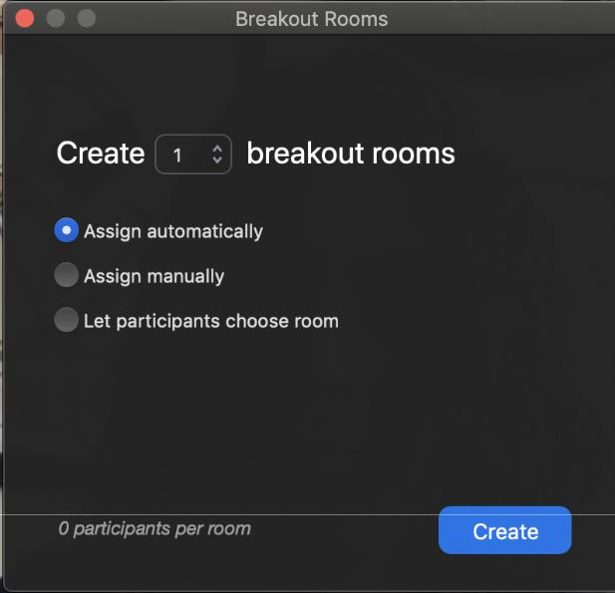

For Teachers



SHARE SCREEN

When enabled you will be able to have participants view what is on your screen.

1. Click green box and arrow that says Share Screen

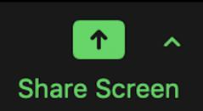

a.

1. In the new window, select the screen you want to share (it will be highlighted blue)
2. Click the blue button in the bottom that says share
3. To stop share, click the red tab at the top of the screen that says stop share

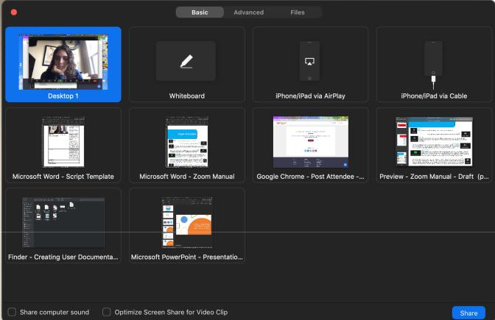

8





PART 4: Host a Meeting

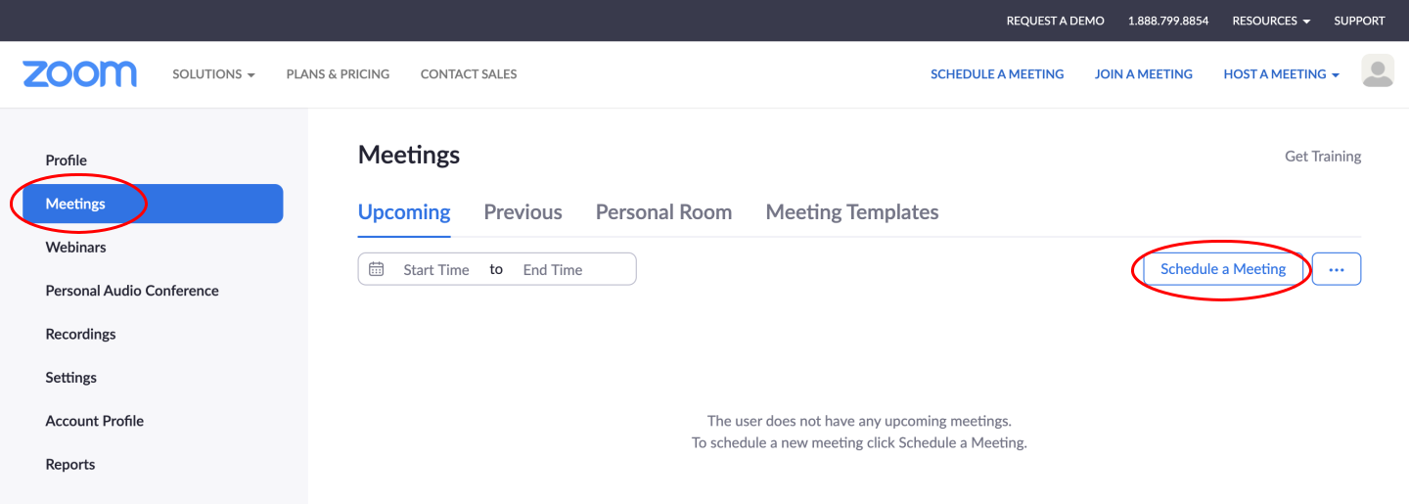

1. From your profile page, click on MEETINGS in the left-hand column
2. Click SCHEDULE A MEETING in the boxes below

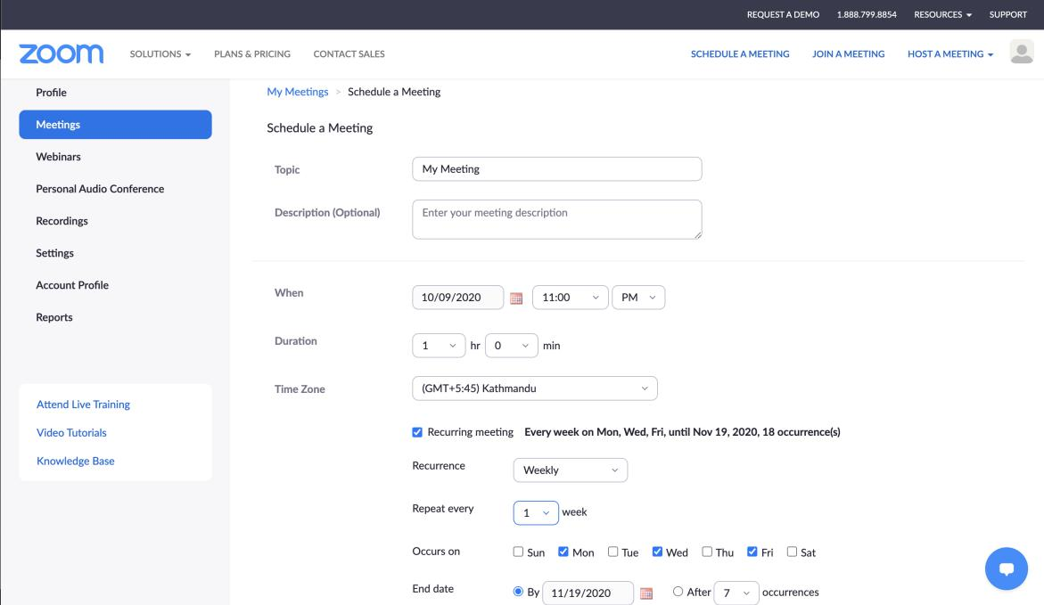

1. Enter the title of the meeting in the topic box
2. Provide a description of the meeting

a. Include your goals, purpose, activities to be conducted throughout the meeting

1. Input the date and time of the meeting

9



1. Input duration of the meeting
2. Adjust the time zone – GMT+5:45 Kathmandu
3. Determine if the meeting is recurring or not
4. Check box if meeting will happen more than once
   * State how frequently meeting will occur
   * Indicate when the meeting will end by indicating a date or max number of occurrences

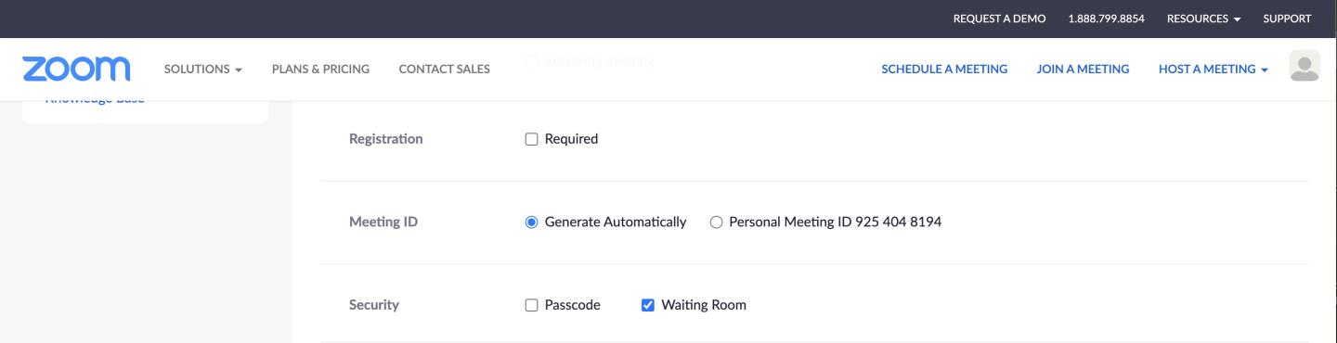

1. Determine if people must register
   1. This requires participants to sign up before attending a meeting
2. Generate the Meeting ID
   1. Zoom will automatically create a meeting ID
   2. Use a personal meeting ID from your personal meeting room
3. Define security measures by enabling a:
   1. Passcode – require participants to input password before joining a meeting
   2. Waiting room – participants must be allowed into the meeting by the host

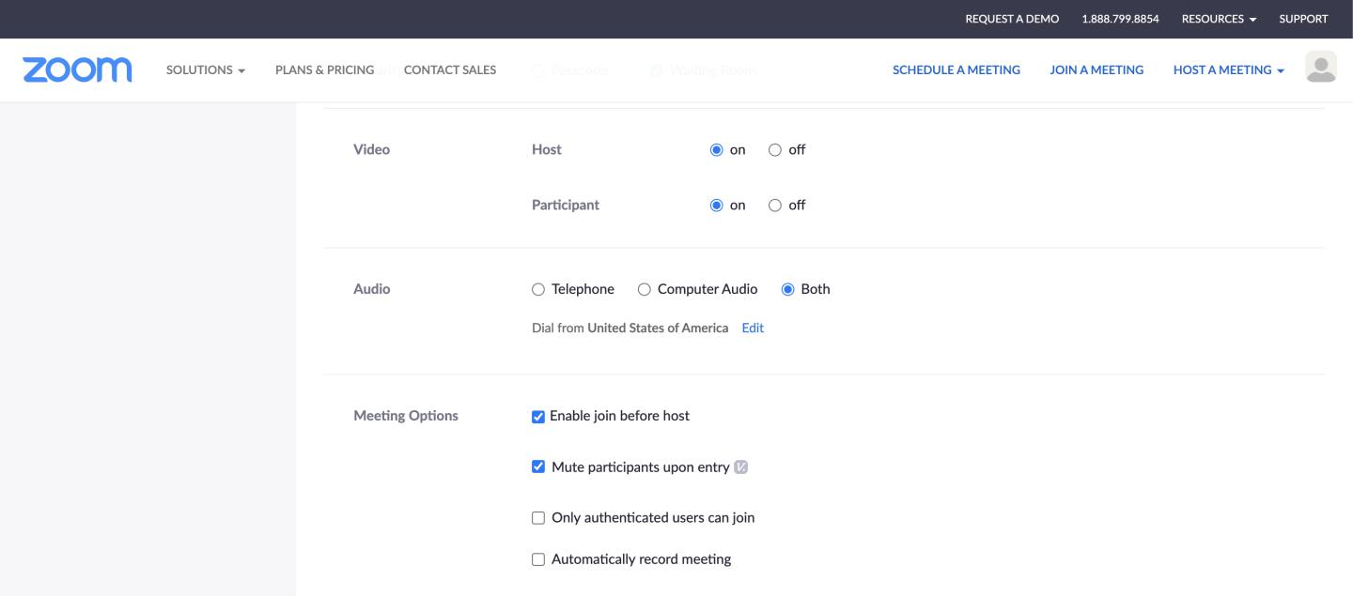

1. Control video and audio of participants
   1. Video can be on or off for participants when they first enter a meeting
2. Choose other meeting options
   1. Enable participants to join before the host

10



1. Mute participants upon entry
2. Only authenticated or registered users can join o Automatically record meeting
   * This will be saved to your Zoom account under recordings

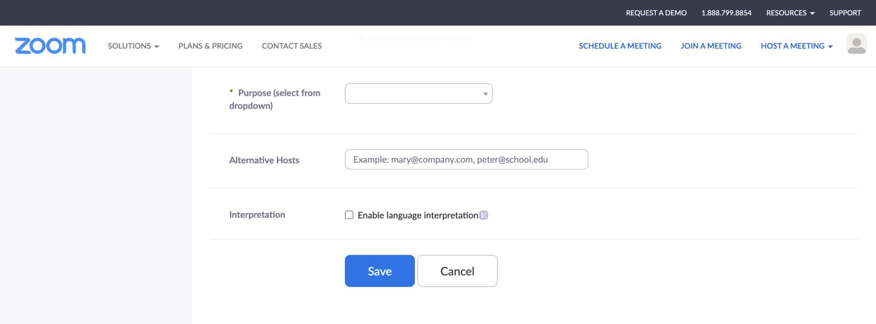

1. Define the Purpose of meeting
   1. Administrative
   2. Research
   3. Student Group
   4. Teaching
   5. Thesis
   6. Dissertation
   7. Training
   8. Other
2. Designate Alternative hosts
   1. These are people who will have similar controls like the host and be able to share their screen
3. Enable language Interpretation
4. Click the blue SAVE button
5. You will be redirected to meeting page with more information about the meeting
6. Email the link and information to your peers!

11



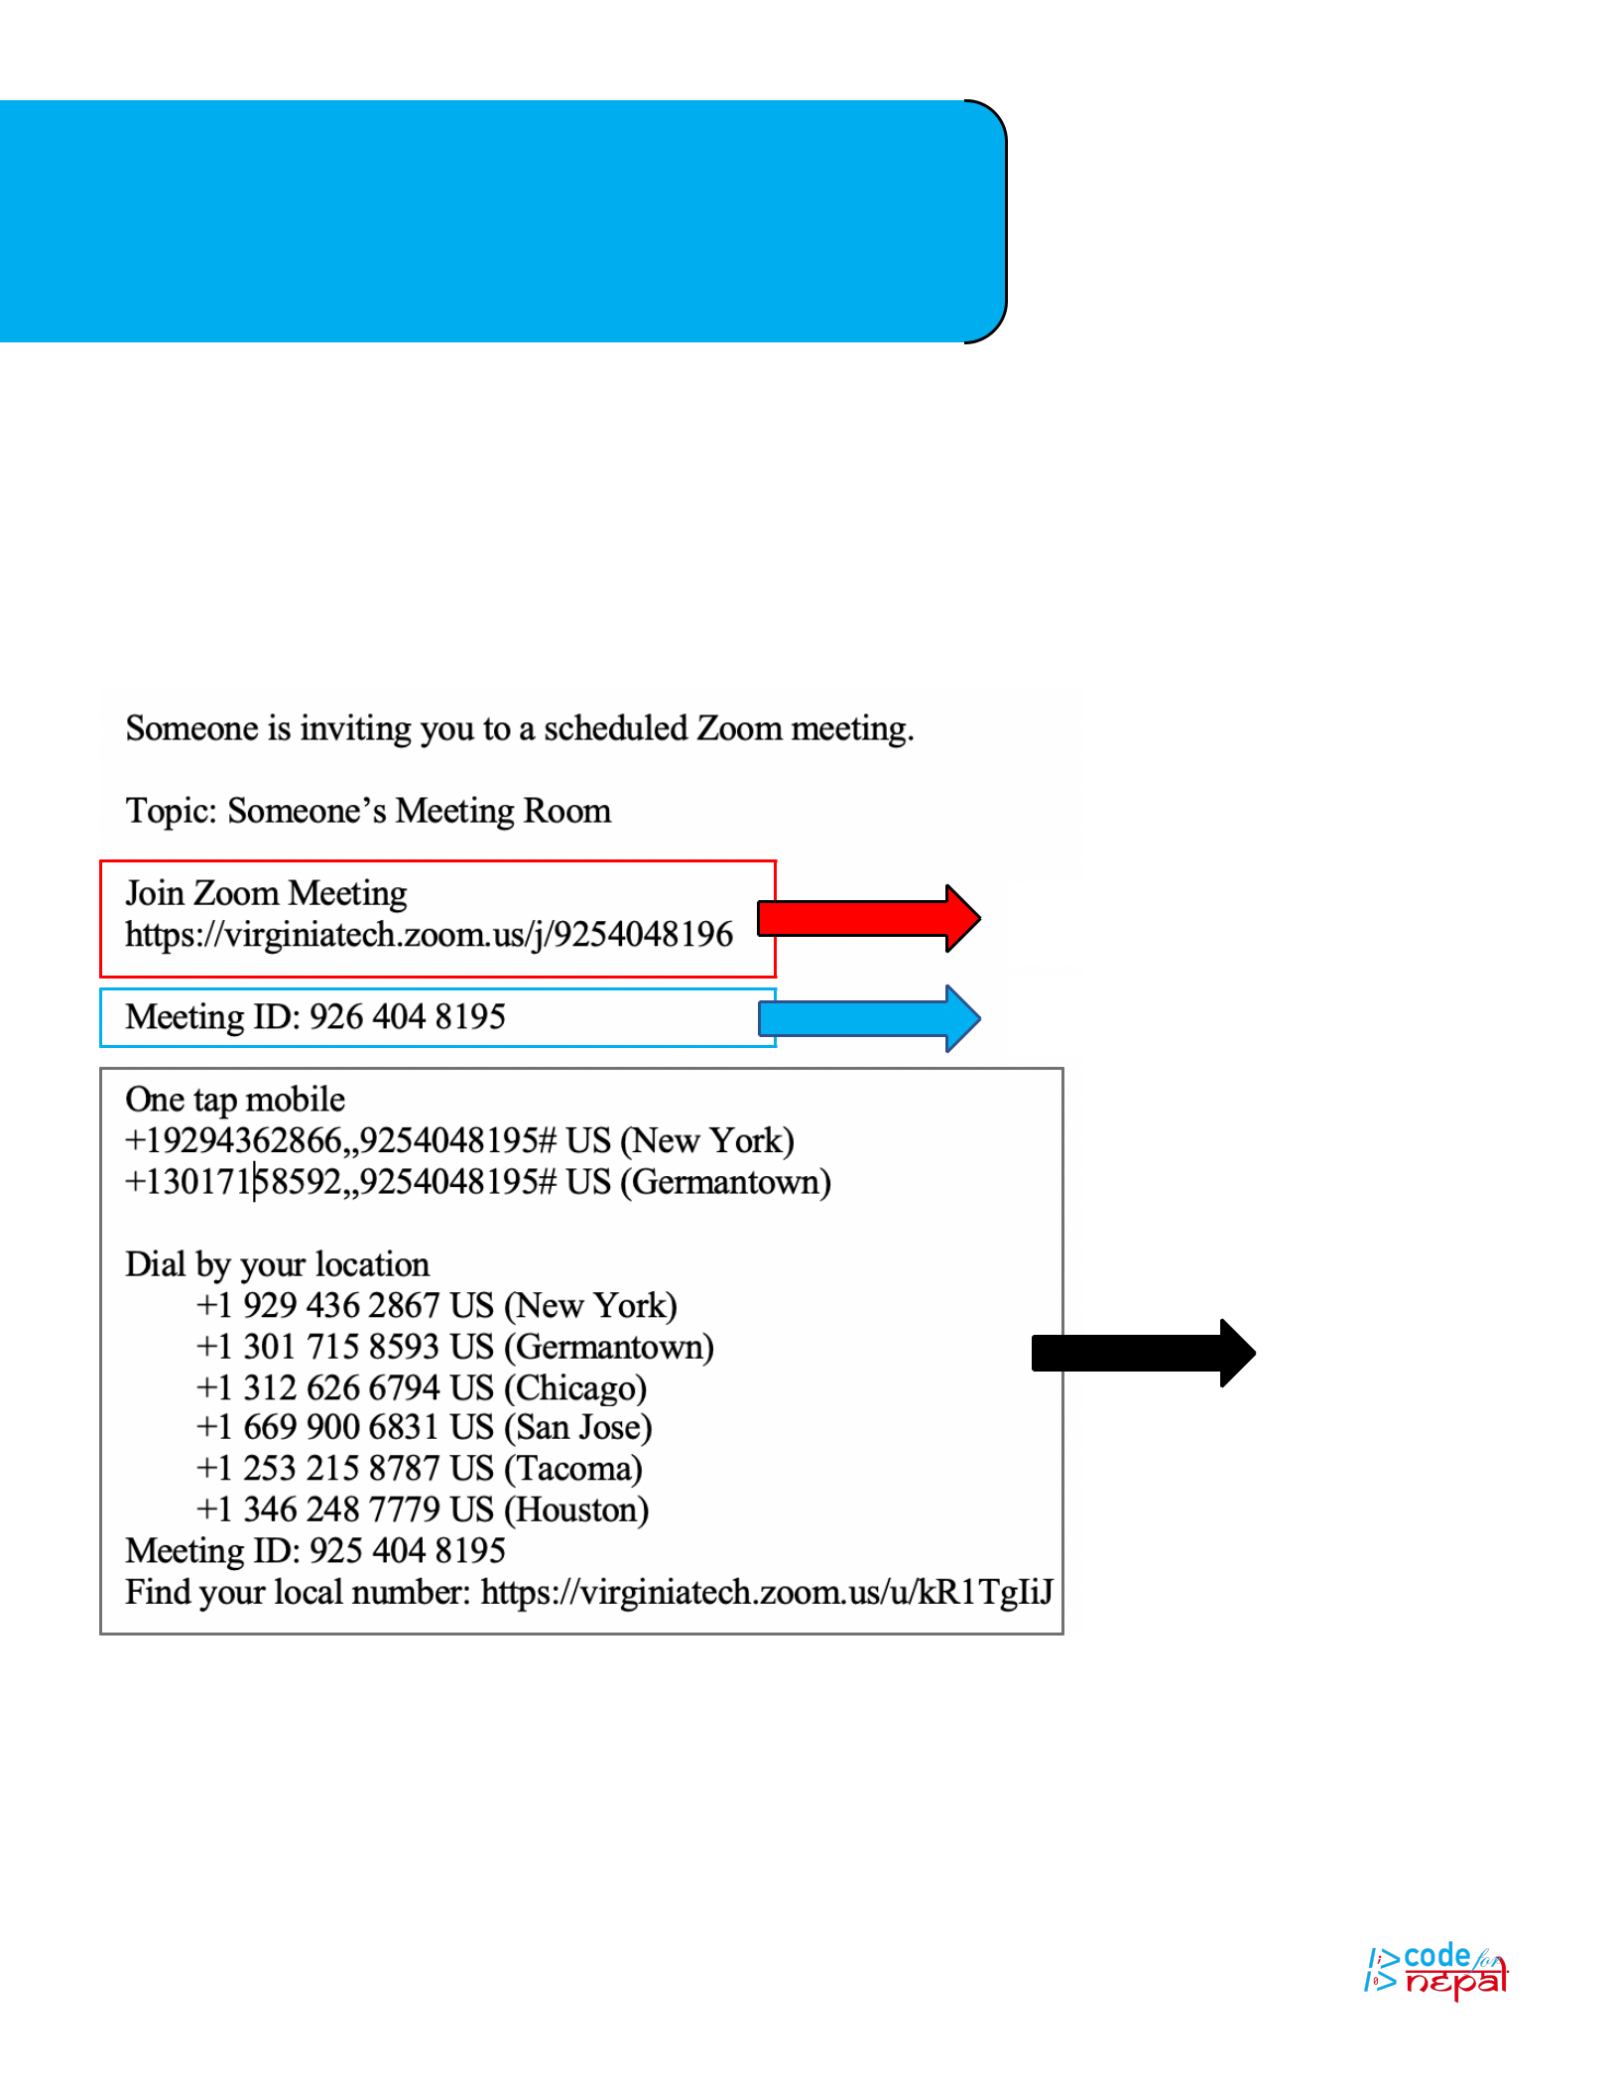PART 5: Join a Meeting

An email will be sent to you with information on how to join a meeting. It has three parts, each with information of how to join a Zoom Meeting. There are three different ways to join access a meeting: by Link, Meeting ID, and by Phone.

Join by Link

Join by Meeting ID

Join by Phone

12



Continued: Join a Meeting

JOIN BY LINK

1. Click the link URL provided
2. Join meeting through browser
3. Open the downloaded app on your computer

JOIN BY MEETING ID

1. Click JOIN A MEETING TAB on homepage of Zoom.us
2. Enter 10-digit code into text box

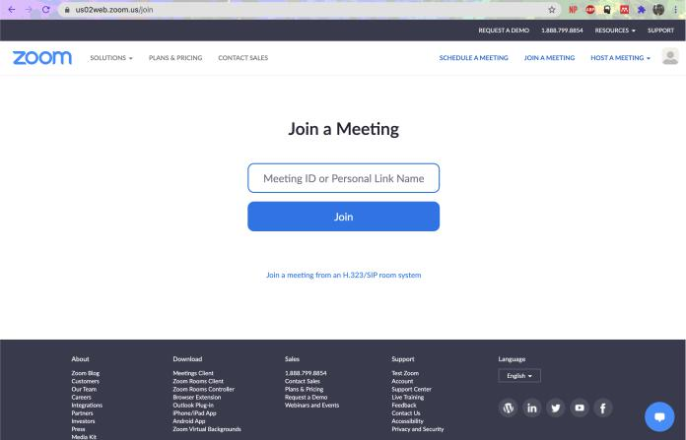

a.

3. Click Join

JOIN BY PHONE – No Wifi Access

1. Dial in-country number provided in email
   1. If not in email check https://zoom.us/zoomconference for specific country number
2. Enter Meeting ID number from email
   1. After last number enter # sign
3. Type your name into the phone
   1. Format: #YourName#

13





THANK YOU



Thank you! For more information, please refer to the Zoom Help Center:

https://support.zoom.us/hc/en-us/articles/360034967471-Quick-

start-guide-for-new-

users#:~:text=Creating%20your%20own%20account,this%20email

%2C%20click%20Activate%20Account.



To get involved with Code for Nepal via donation or volunteer work please go to:

https://codefornepal.org/help/

14

